Better Pavement Management for Better Road Maintenance
Minnesota’s Better Patching for Better Roads 
When we do the right road and bridge pavement maintenance – in the right way, in the right place and at the right time – only then are we right on the money. This means we have taken every measure to proactively protect, maintain and preserve the roads we have. In doing so, we maximize our taxpayers’ investments into better, longer-lasting roads for smoother, safer and more efficient travel.
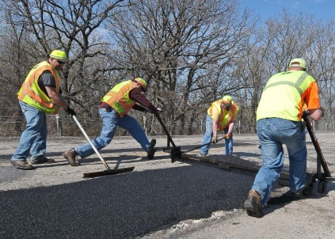
That is why the Better Patching for Better Roads initiative, which began in Minnesota just a few years ago, has gained momentum. It has become an officially recognized, ongoing effort to better maintain the integrity – and maximize the longevity – of all of our state roads.
In 2013, funding was extended beyond traditional capital roadway expenditures when MnDOT adopted the Better Patching for Better Roads approach to pavement maintenance at the district level, or regional, level. The agency allocated $4 million specifically to finance roadway preservation through targeted preventive and routine patching maintenance designed to achieve more lasting performance. These funds were used for materials, labor, buying or renting equipment,
or contract work in all eight MnDOT districts.

The Better Patching for Better Roads approach has gained widespread support in Minnesota due to highway maintenance needs and the demonstrable performance outcomes resulting from dedicated funding.

Subsequently, as a means to maximize its level of investment toward pavement products, services and life cycles, MnDOT pressed forward with Better Patching for Better Roads as the agency’s preferred approach to road maintenance. In 2014, the Minnesota State Legislature took action on the need for ongoing investment in pavement maintenance specific to potholes. Recognizing the heavy toll the winter of 2013-2014 had taken on state roadways, legislators granted an additional $10 million as part of a supplemental budget. These additional funds were invested by MnDOT districts using the Better Patching for Better Roads approach where ever possible.

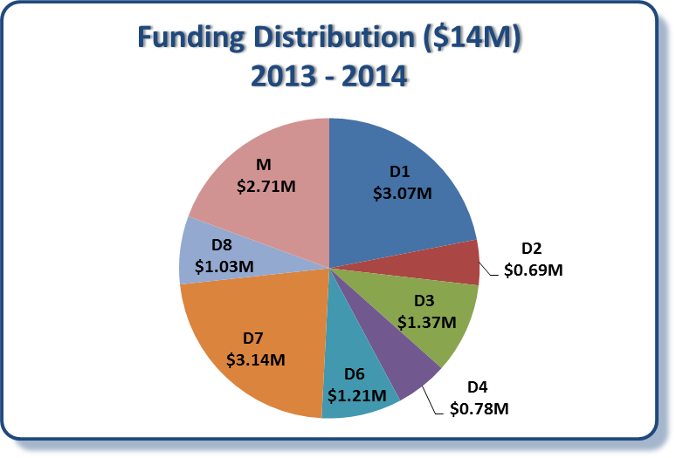

Going forward: The 2014 State performance measures show that 501 miles of state highways in Minnesota
are classified as in “poor” condition. Without additional investment dedicated to pavement construction, that number will increase to 987 miles by 2018. It is now more important than ever to continue investing in new pavement construction as well as maintaining our existing roads with the Better Patching for Better Roads approach.

For More Information
Visit: mndot.gov
Or contact: Sue Lodahl, Assistant State Maintenance Engineer/MnDOT, 651-366-3549 Sue.Lodahl@state.mn.us

